Magic Invitational: Bob Maher
Bob Maher
The Magic Invitational was a perfect example of the things that I enjoy the most about Magic. The people were fun, the event was exciting, and it was in a great place. Everyone at the event made it fun. The staff, the spectators, and the players all made the invitational what it should be.
The week started with a very long plane trip. Very, very long. Much of the plane ride was spent with playing a "Bring Your Own Block" deck against the new World Championship decks that Jon Finkel brought. Occasionally Chris Pikula would wake up and complain about how horrible he felt.
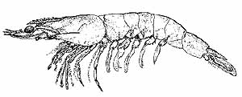
When we arrived at the hotel we quickly checked in and showered. A few of us then decided to go to the buffet for some lunch. This was our first introduction to the international love of prawns. Never before have I seen someone carrying a plate overflowing with shrimp with beady little eyes. It wasn't just the prawns that bothered me, though, it was the apparent craving for them that the people had. There was a line at the buffet for the prawns. Everything else was prepared in some moderation, except the prawns. There was a trough of prawns. I think we were the only people in the place that didn't have a heaping pile of prawns. Even the thought of how many prawns I saw people eat at the buffet confounds me.
That evening was the player meeting. We all got the rundown on what was going on that week and we turned in our potential cards. Ben Rubin's card baffled us all. Many conversations that week began with, "So Ben, what does your card do?" After seeing how confusing his card was to the Invitationalists, I can't imagine what the card seemed like to an average player.
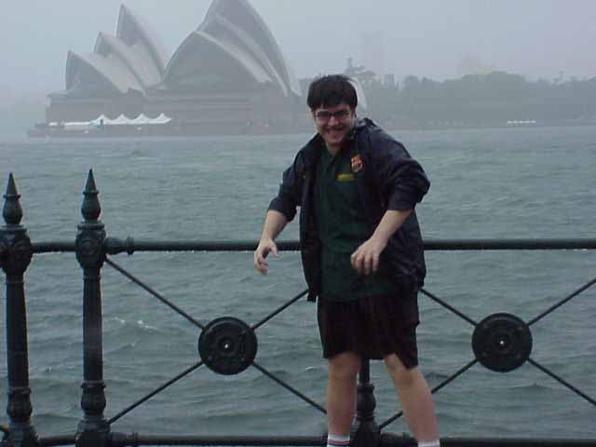
The next day was the tour. It rained. Zvi worked it for the camera like none other. Some of the players actually tried to play a digeridoo. Everyone on the bus was hearing stories of the deck that Dave Williams had just played at a Grand Prix. We all guessed at what was in his deck and talked about how fun it would be to Obliterate someone. We did all we could to entertain ourselves while it rained.
Much of the rest of the week is blurred together, so I will separate it into Magic and non-Magic.

Magic
Duplicate Sealed:
I played red and green with a black splash.
Wacky as always, I had a hard time deciding what to build. I decided to ignore all of the combos and try to beatdown. I didn't really succeed, losing to Ben Rubin and his 1 cc Winter Orb, Gerardo and his Winter Orb, and beating Darwin.
Bring your own Block:
I played Te/Vi/Al Counterpost
My deck seemed good to me, but that is why I am not a deck builder. The only win I got was in the mirror match. That game included Gary Wise and I having more soldier tokens in play then I care to remember. I believe that we had well over 50 tokens and then a spell stack with 12 or so spells. When the dust finally cleared I had won. I went on to lose to Jon Finkel and Ryan Fuller.
Solomon Draft:
I really felt that this was my best format coming into the Invitational. I still feel the same way after. I was lucky that I was able to figure out what I wanted to do in each draft. I knew that when I saw that all the cards were gold that I really wanted to play red. I realized in the Legend draft that it would be really slow. I also realized in the color dependent draft that Whim of Volrath was a powerhouse. I would have been 3-0 in this format if I had remembered to pay cumulative upkeep on Gallowbraid. I beat Pikula and Shvartsman, but lost to Ishii.
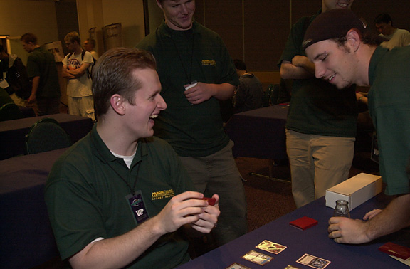
Deck Auction:
To make a long story short, I got Loconto's deck. I knew it looked bad on paper but I figured it couldn't be that bad when it played. I was right. The deck was far worse than I had even imagined. I sideboarded so much, every match, that I have no idea how that man won a tournament. I got lucky against Dave Price that Control Magic is so good against Verdant Force and that he didn't draw mana in game 3. I got lucky against Zvi in that a first-turn Ivory Tower is a beating against Bloom-Drain. I was lucky in game two that Zuran Orb is even better than Ivory Tower. I lost to Trevor Blackwell in three games. All in all, I got very lucky with the deck.
Type 1:
I played 5-color control with Obliterate
I beat Noah Boeken by having played more Type 1 than he has. I lost to Mike Long 2-1 without any of the games really being a game. Last, I lost to Kai Budde because I am a bad player. He was playing Trix. He cast Abeyance on me because I have a Seal of Cleansing in play. In response, I Vampiric Tutor and put Obliterate on top. I then don't Seal his Bargain and lose to the combo that turn. If I would have sealed the Bargain, he would have just played an Illusions, Necroed, and said go. Oh well. I win game two. Game three, Negator was killing me, he was at three from Necro, and I couldn't draw my Urza's Rage.

The Rest
One of the highlights of my trip was getting to know Ben Seck. He was a great all-around guy. He loaned everyone cards, showed us around town, and was great company all week. The highlights of the week that I can remember I will try to relate to you. I imagine that you had to be there for many of them.
Many of us had birthday parties at lunch. Complete with cake and ice cream.
Basketball games with a bunch of Magic people are really a sight to see.
A casino at the tournament, how Magic was meant to be.
Chris Pikula, enough said. (Should be a permanent part of the Invitational)
Jon Finkel, regardless of what he says, dressing like a sailor.
All of the dinners with everyone, always a riot.
Gunslinging with Gary Wise, in 2 on 2 draft, against all comers.
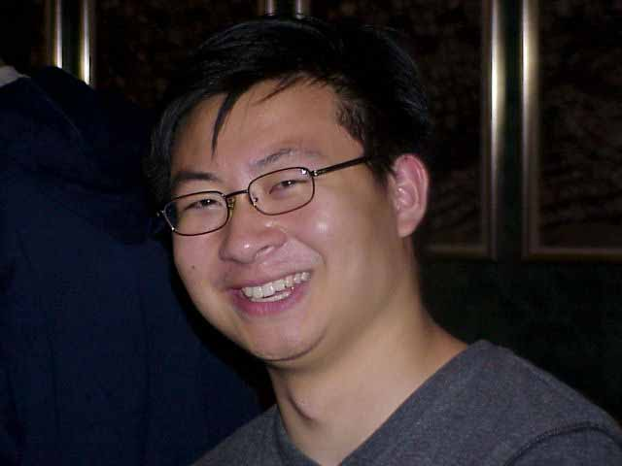
The Ben Seck
One of my favorite stories from the weekend involved the 2 on 2 drafting Gary and I did. All day Gary and I had yet to lose a match. Gary decided to get on the microphone and announce that the people of Australia couldn't draft and had no chance against us. He asked the crowd to choose two people to represent them in a draft. One of the people they chose was Ben Seck. The problem was that Ben was in the last round of a PTQ and he was playing for Top 8. Rather than have someone replace him, he stands up, concedes, and walks over for the draft. Now that was really something. It was the last round, starting game 3, playing for Top 8. I was amazed, and I hope the Australians appreciated him standing up for them.
The Invitational was a great time and I will always remember it. It was great meeting Ben Seck and Rod Ho, they are great guys. I enjoyed everyone's company at the event and I wouldn't change a thing. I hope this let you see the event at least partially through my eyes.

